 |  | BAKER COLLEGE
CIS421B: | DATABASE ADMINISTRATION I  4 Quarter Hours  Syllabus | 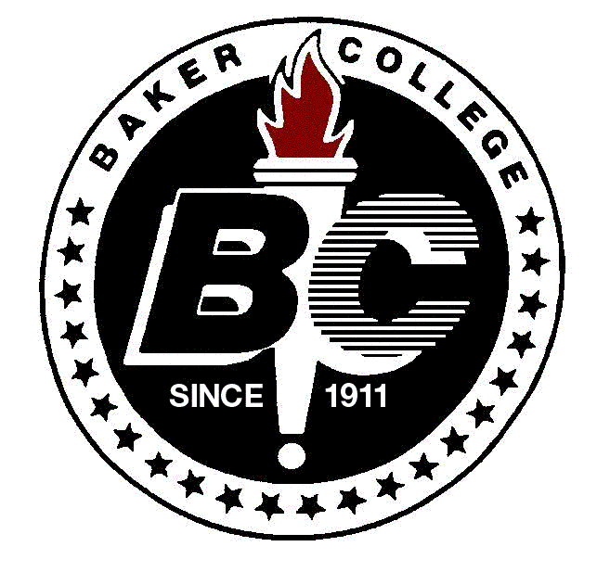
 |  | ©COPYRIGHT 1997
INSTRUCTOR INFORMATION
INSTRUCTOR NAME: Steven King
OFFICE HOURS: 5:15 p.m. – 6:00 p.m. Tuesday Room 243
CONTACT INFORMATION: Email Address: Steven.King@baker.edu Voice Mail: (248) 276-8250 X1500

ATTENDANCE POLICY: Attendance is necessary for your success in this course. Attendance will be taken within the first ninety minutes of class. If you arrive late to class, it is your responsibility to notify the instructor that you are present.
COURSE SPECIFIC INFORMATION
COURSE DESCRIPTION: Exposes students to database administration and the duties of a database administrator (DBA) to include database monitoring, backup and recovery, troubleshooting, and tuning for reliability and performance. Students will install, configure, and maintain an RDBMS including security, backup and recovery operations, and performance tuning. Prerequisite(s): CIS302A or CIS331 Co-requisite(s): None.
TEXTBOOK(S): Oracle 10g Database Administrator: Implementation and Administration. Gavin Powell, Carol McCullough-Dieter. Course Technology. © 2007. ISBN: 1-4188-3665-6. ISBN-13: 978-1-4188-3665-8.
ADDITIONAL MATERIAL(S): One USB Flash Drive
COLLEGE SPECIFIC INFORMATION
TUTORING: See your instructor for recommendations on tutoring, Learning Support Services, and/or other help.
HONOR CODE: There are four possible consequences for violating Baker College’s Honor Code. The College may implement any or all of the following: failure of the assignment, failure of the course, expulsion from the College, rescinding a certificate or degree. Please refer to the Student Handbook for further details.
COLLEGE POLICIES:
- Eating and/or drinking in class is prohibited.
- Smoking is allowed only in designated smoking areas.
- Children are not allowed in the college buildings. This includes regular class and lab periods. Children may not be left unattended anywhere, especially in the Student Center or Library. Children may come into the building, rather than be left unattended in a vehicle, while a parent conducts college business, picks up a check, drops off an assignment, etc.
- Pagers and cell phones must be kept in an inaudible mode in the classroom.
- No extra credit is available in this course per Baker College policy.
ADA STATEMENT: Baker College is committed to addressing the needs of students who meet the criteria for special accommodations. It is the College’s policy to comply fully with federal and state laws, including Section 504 of the Rehabilitation Act of 1973 and the Americans with Disabilities Act of 1990 (ADA), regarding students with disabilities. Information concerning the College’s policies and procedures related to disability can be found in the Student Handbook and on the Baker College web site: www.baker.edu/departments/academic/counseling/specialneeds.cfm.

CLASS: CIS421B Section#: 3078 DATABASE ADMINISTRATION I
SEMESTER: Winter 2009

INSTRUCTOR: Steven King

CONTACT INFORMATION : EMAIL ADDRESS: Steven.King@baker.edu
VOICE MAIL : (248) 276-8250 Extension 1500

CLASS TIME: Tuesday 6:00 p.m. – 9:40 p.m.
Room 243

10 Week Course. Begin Date: 1/13/2009 End Date: 3/17/2009

OFFICE HOURS: 5:15 p.m. – 6:00 p.m. Room 243
By Appointment.

ADDITIONAL MATERIALS USB Jump Drive
RECOMMENDED:

CLASS POLICIES: - Late assignments will be marked down 20% each week late. *
- Quizzes not taken during scheduled class time must be made up within one week of the date of the
quiz* and must be taken during the Office Hours for the Instructor. Final Exam must be taken during the scheduled date & time. *
- No assignments will be accepted after Week 10 of Class.
- It is the student’s responsibility to communicate any problems concerning assignment
completion to the instructor as soon as possible.
- All students must turn in their own work. Plagiarism or copying material
(electronically or written) will not be tolerated and a zero score will be assessed.

Approx. Percentage

GRADE EVALUATION: Assignments /
Homework 60%
Quizes 20%
Final Exam 20%
----------------
100%

FINAL GRADE CALCULATED: Total Points Earned divided by Total Points Possible.
Grades will be posted on the Blackboard system.

GRADING SCALE:

A = 100-94 A- = 93-90 B+ = 89-87 B = 86-83 B- = 82-80
C+ = 79-77 C = 76-73 C- = 72-70 D+ = 69-67 D = 66-63
D- = 62-60 F = 59-0

ATTENDANCE POLICY: Attendance is necessary for your success in this course. Attendance will be taken within the first ninety minutes of class. If you arrive late to class, it is your responsibility to notify the instructor that you are present.

STUDENT SUCCESS POLICY: Since your first assignment will be critical to your success in the class, you will be given an extra week (upon request) to finish the first assigned assignment(s) from Class 1 without point deductions.

* This may be waived by approval from the Instructor if prior arrangements have been made

8/20/06 |  | Effective for Fall, 2006
 |  |  |  | BAKER COLLEGE
CIS421B | DATABASE ADMINISTRATION I  4 Quarter Hours  Student Learning Outcomes
 |  |  | ©COPYRIGHT 1997

1. | Describe the Oracle architecture and its main components
2. | Identify common database administrative tools available to a DBA
3. | Identify the features of the Oracle Universal Installer and the Oracle Enterprise Manager and their uses
4. | Create and manage initialization parameter files
5. | Create a database manually and by using Oracle Database Configuration Assistant
6. | Identify the uses of the data dictionary and query the contents
7. | Describe the contents of and explain the uses of the control file
8. | Manage and maintain online redo log files
9. | Monitor the use of diagnostic files
10. | Describe the logical structure of tablespaces within the database
11. | Create and manage tablespaces
12. | Describe the logical structure of segments within the database
13. | Obtain information about storage structures from the data dictionary
14. | Describe the purpose of undo data
15. | Manage passwords using profiles
16. | Administer profiles
17. |  | Create new database users and monitor information about existing users
18. |  | Identify and manage system and object privileges
19. |  |  | Create, modify, and manage roles
These SLOs are approved for experiential credit.
SLOs Developed by Shen Chow/CT

Assignment Sheet

NOTE: It is required that all exercises be completed within the Chapter.
Provide one screen prints FOR EACH exercise grouping within the Chapter to earn points

Class | Reading Assignments  For the Following Class | Lecture from Text /  Extra Material | Homework  All homework should be submitted typed or written very neatly | Quizzes / Final Exam
Class 1 | Chapter(s) 1,2,3 | Chapter(s) 1 | Install Oracle components.  Chapter 1 – Review Questions. | None
Class 2 | Chapter(s) 4,5 | Chapter(s) 2,3 | SQL Review  Web Research & Analysis Assignment.  Chapter 2 – Review Questions.  Chapter 2 – Hands-on Assignments Paes 84-85.  Chapter 3 – Hands-on Assignments Pages 133-135. | None
Class 3 | Chapter(s) 5,6 | Chapter(s) 4,5 | Chapter 4 – Review Questions.  Chapter 4 – Hands-on Assignments Pages 195-196.  In Class Project #1. | None
Class 4 | Chapter(s) 7 | Chapter(s) 5,6 | Chapter 5 – Hands-on Assignments Pages 247-248.  Chapter 6 – Review Questions.  Chapter 6 – Hands-on Assignments Pages 288-289. | Quiz #1 covering Chapters 1-4
Class 5 | Chapter(s) 8,9 | Chapter(s) 7 | Chapter 7 – Review Questions.  Chapter 7 – Hands-on Assignments Pages 352-354 PICK ANY 1 problem.  In Class Project #2 | None
Class 6 | Chapter(s) 10 | Chapter(s) 8,9 | Chapter 8 – Hands-on Assignments Pages 391-393.  Chapter 9 – Hands-on Assignments Pages 460-463. | None
Class 7 | Chapter(s) 11,12 | Chapter(s) 10 | Chapter 10 – Hands-on Assignments – Pages 484. | Quiz #2 covering Chapters 5-9
Class 8 | Chapter(s) 12 | Chapter(s) 11,12 | Chapter 11 – Hands-on Assignments – Pages 514. | None
Class 9 | Review Chapters  1-12 | Chapter(s) 12 | Chapter 12 – Review Questions. | None
Class 10 | NONE | Final Exam |  | Final Exam Covering all Chapters Assigned

Grading - See Syllabus for distribution.
The Reading Assignments will be reviewed in the following class. You are expected to Read the Chapter(s) before class (except for class 1 in which material will be covered during this class).
All Homework is due on the day of the Quiz or Final covering the material unless indicated on the Assignment or Exercise.
In-Class Assignments will be distributed as needed to support discussions/reading material and will be scored/treated as homework assignments.
You are responsible for contacting the Instructor to obtain In-Class Assignments and handouts if you are absent.

*Assignment schedule is subject to change at the Instructors discretion.

